Chapter 6, Solution 6.

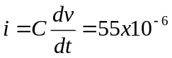 times the slope of the waveform.
For example, for 0 < t < 2,

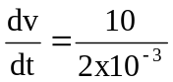

i = 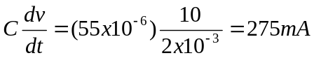
Thus the current i(t) is sketched below.
i(t) (mA)
–275
4
6
8
2
10
12
275
t (msec)

